



HEALTH ADMINISTRATION PROCEDURES
(610)
NATIONAL 2024

Multiple Choice:
40 @ 3 points each ____________ (120 points)
Production:
Job 1: HPIP Transcription ___________ (60 points)
Job 2: SOAP Transcription ____________ (60 points)
TOTAL POINTS _____________ (240 points)

Test Time: 60 minutes

GENERAL GUIDELINES:
Failure to adhere to any of the following rules will result in disqualification:
- Member must hand in this test booklet and all printouts if any.
- No equipment, supplies, or materials other than those specified for this event are allowed in the testing area. No previous BPA tests and/or sample tests (handwritten, photocopied, or keyed) are allowed in the testing area.
- Electronic devices will be monitored according to ACT standards.

EXAM GUIDELINES:
- Ensure this test booklet contains Jobs 1-2.
- Key all jobs according to the instructions given.
- Correct any and all formatting, spelling or grammar errors. Use the formatting guide in the Style & Reference Manual.
- Your name or initials should not appear on any work you submit. Use your contestant number in any occasion you would normally key your reference initials.
- In the lower right-hand corner of ALL work submitted (unless otherwise specified) key your contestant number and job number.
- If you complete the event before the end of the time allotted, notify the proctor. Time could be considered a factor in determining a winner when there is a tie score.
- Place your scoring sheet on top of your Jobs. Jobs should be in numerical order.

PRODUCTION STANDARDS
0 Errors | 100 Points
1 Error | 90 Points
2 Errors | 70 Points
3 Errors | 50 Points
4+ Errors | 0 Points

Multiple Choice

1. | C
2. | B
3. | A
4. | D
5. | B
6. | A
7. | A
8. | B
9. | B
10. | A
11. | B
12. | B
13. | D
14. | B
15. | D
16. | C
17. | D
18. | A
19. | C
20. | C
21. | C
22. | C
23. | D
24. | B
25. | A
26. | D
27. | B
28. | B
29. | C
30. | B
31. | B
32. | D
33. | D
34. | C
35. | A
36. | C
37. | D
38. | C
39. | C
40. | C

Patient Name: Bridget Williams PCP: Dr. Joan Watson
Date of Birth: 12/04/1996
Date of Exam: Day before date of student’s exam (Example 01/03/2024) Sex: Female

HISTORY OF PRESENT ILLNESS: Patient is a 27-year-old female who is being seen for recurrent headaches for the past 6 months. She does not have a previous history of headaches.

MEDICATIONS: Patient is taking a women’s multivitamin daily.

PHYSICAL EXAMINATION: BP 126/66, RR 14 breaths/minute, HR 68 bpm, O2 97%. Exam is otherwise negative.

IMPRESSION: Patient appears fatigued. She states that she has had increased stress recently and sleep and nutrition have not been a priority.

PLAN: CBC and thyroid panel ordered. Patient is to return to the office to review lab results in 2 weeks.

________________________
Rob Williams, M.D.

RW:######### (Member ID Number)

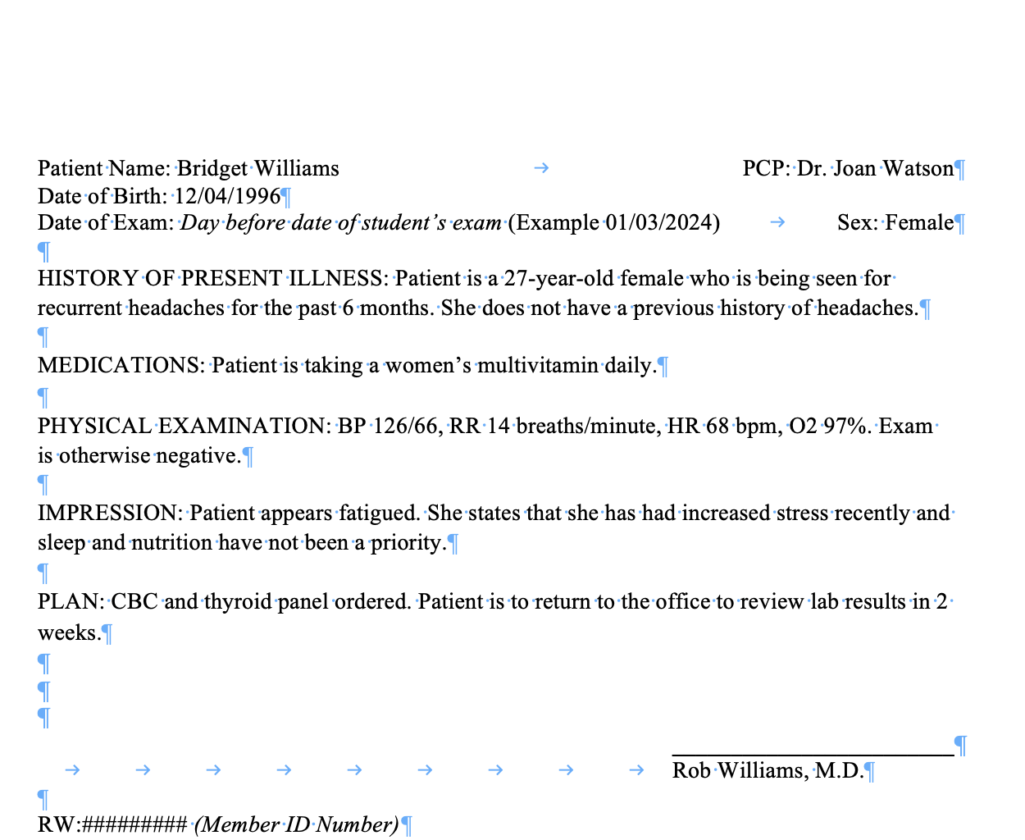
For graders: Please use the Style and Reference Guide for grading guidelines. Top margins should be 2.5 inches. Side margins should be 1 inch. The physician’s signature line should be right aligned and 2 inches long. All text should be Times New Roman, size 12.

Patient Name: John Adams PCP: Dr. Samuel Sodhi
Date of Birth: 10/11/1984
Date of Exam: Day before date of student’s exam (Example: 01/03/2024 Sex: Male

SUBJECTIVE: Patient is a 40-year-old male who complains of left knee pain. He states he got in a car accident two years ago and has had knee pain ever since.

OBJECTIVE: BP 132/78, HR 74, RR 12.

ASSESSMENT: 1. Left knee swelling
2. Decreased mobility in left knee

PLAN: Order an MRI of the left knee. Patient to follow-up in two weeks to review MRI results. Activity restrictions- No running or twisting movements with the left lower extremity until follow-up visit.

________________________
Jane Smothers, D.O.

JS:######### (Member ID Number)

D: (Day before date of student’s exam, Example: 01/03/2024)
T: (Day of student’s exam, Example: 01/04/2024)

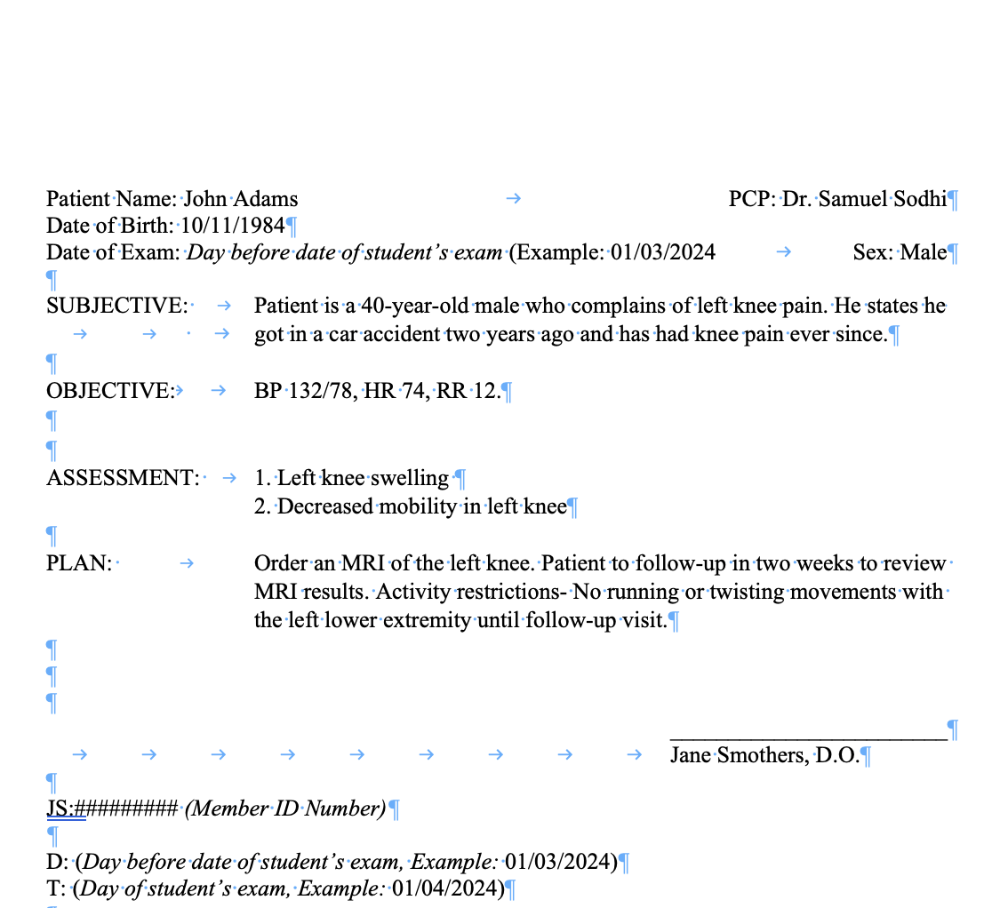
For graders: Please use the Style and Reference Guide for grading guidelines. Top margins should be 2.5 inches. Side margins should be 1 inch. The physician’s signature line should be right aligned and 2 inches long. All text should be Times New Roman, size 12.

